Activity Worksheet: Water-buffet with different vessels

Introduction:
Water tastes different, depending on temperature or region of origin. What makes the taste in the water? In this experiment children try tapwater from different vessels. Is there a difference, if we drink water from a smooth or rough plastic vessel, from thick or thin glass, from a paper cup, a porcelain cup or from a metal mug. What do we like most?

Target group: pre-school, primary school
Learning goals: taste and acceptance of water depends on the material of vessel, find out what´s your favorite drinking vessel
Time needed: 10 minutes

Tools and materials needed:
- jug with fresh tap water
- different drinking vessels for each child, e.g. smooth or rough plastic vessel, thick or thin glass, porcelain cup, metal mug

What to do:
Prepare a water buffet. Children are guided to try tap water from different vessels.
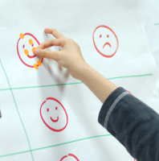
- How is the mouth-feeling?
- Is there a difference in taste depending on the drinking vessel?
- Which one do you like most? Why? The mineral waters should be still, as carbon dioxide drowns out the taste.
Capture the result on a poster.

During the tasting, the differences in acceptance of water from different vessels become aware.
Sometimes, children think, they don´t like water, but in fact, it is the vessel that they do not like to feel on the lips.

Children love tasting and are very focused and sensitive.

