Activity Worksheet: Assess Beverages
Introduction:
In this activity pupils/students rate drinks and assign them to the traffic light.
Sugar sweetened drinks are responsible for the growing obesity in children and jouth. Reason: The high sugar content provides many calories, but the drinks do not saturate. Therefore, too many calories are easily absorbed. Sugar free drinks mostly contain artificial sweeteners. These are not recommended in schools, as it is easier for children to exceed the recommended limits for these substances because of their low body weight. On the other hand, light drinks are usually too sweet. The desire for sweets is even stronger. Of concern is also the content of acids in lemonades. They attack the tooth enamel.
The best drinks are water, fruit or herbal fusions as well as natural fruit juices, diluted with water. For all other drinks: Look at the label! High sugar levels, sweeteners, artificial colors, added vitamins or caffeine are not recommended for children.

Target group: primary schools, secundary schools
Learning goals: evaluate ingredients of beverages, consumer education,
Time needed: 20 minutes

Tools and materials needed:
- Instruction sheet
- Approximately 20 different beverage packs (tip: collect from school garbage cans)
- 3 traffic light discs (red, yellow, green)

What to do:
Preparation: Set up drinks packs, place traffic light cards.
Implementation: Pupils/students assign the drinks to the traffic light (green: recommended drink, red: not recommended drink, yellow: beetween – not to good and not too bad). Joint review and discussion.

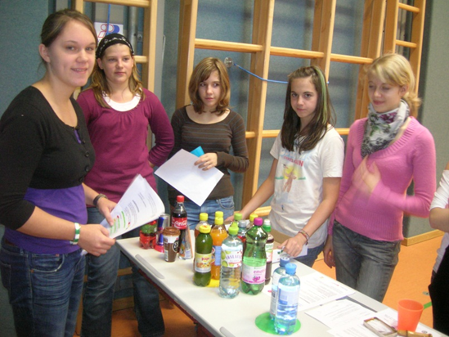

Worksheet for students and assessment criteria (for review) - see next pages.

Hungry Minds:
Updated list of sugar- and sweetener content in drinks (German):
https://www.sipcan.at/getraumlnkeliste.html

Sugar and sweeteners: https://ec.europa.eu/jrc/en/health-knowledge-gateway/promotion-prevention/nutrition/sugars-sweeteners

Worksheet: Assign drinks to the traffic light
- Here you can find many different drinks - some of them you will certainly know from home, from advertising or from the supermarket shelf.
- Next to it are a green, a yellow and a red disc - a traffic light!
- Assign these drinks to the traffic light:

Not recommended as school-drink

OK as school-drink (not ideal, but not too bad)

Ideal drink fo school

Note:
Whether a drink is ideal, OK or unsuitable depends on the ingredients and ingredients. Sugar content, sweeteners, fruit content, vitamins etc. play a role here.
Pay attention to the information on the package!

Worksheet: Assessment criteria

    - Ideal drinks are water or fruit/herbal fusions
    - No artificial sweeteners!
    - Sugar content max. 2,5g/100ml


    - No artificial sweeteners!
    - Sugar content max. 6,7g/100 ml (including naturally contained sugar)

Sugar content can be seen at the nutrition label on the back side of packaging.

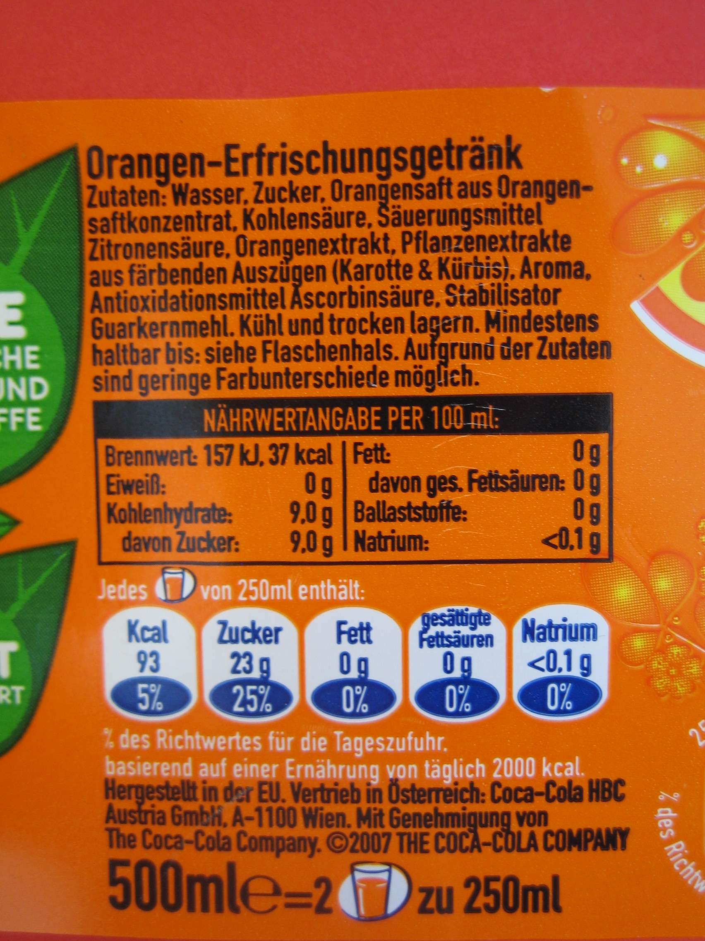
Artificial sweeteners you find on the ingredients list. Sweeteners are e.g. aspartame, steviolglycosid, aspartame-acesulfame, cyclamate, neohesperidin DC, saccharin, sucralose, thaumatin.

